9. TRAVELLING SALESMAN PROBLEM

Aim:
To implement the Travelling Salesman Problem (TSP) using the Brute Force Search algorithm in Python and determine the minimum-cost tour that visits every city exactly once and returns to the starting city.

Objective :
To find the shortest possible route that visits all cities exactly one time and returns to the starting city by evaluating all possible tours.

Algorithm:

- Represent the cities using a cost (distance) matrix.
- Select the first city as the starting point.
- Generate all possible permutations of the remaining cities.
- Calculate the total travel cost for each tour.
- Compare the cost with the current minimum cost.
- If the current tour has a lower cost, update the minimum cost and best path.
- Continue until all possible tours are evaluated.
- Display the optimal path and minimum travel cost.

Flowchart :

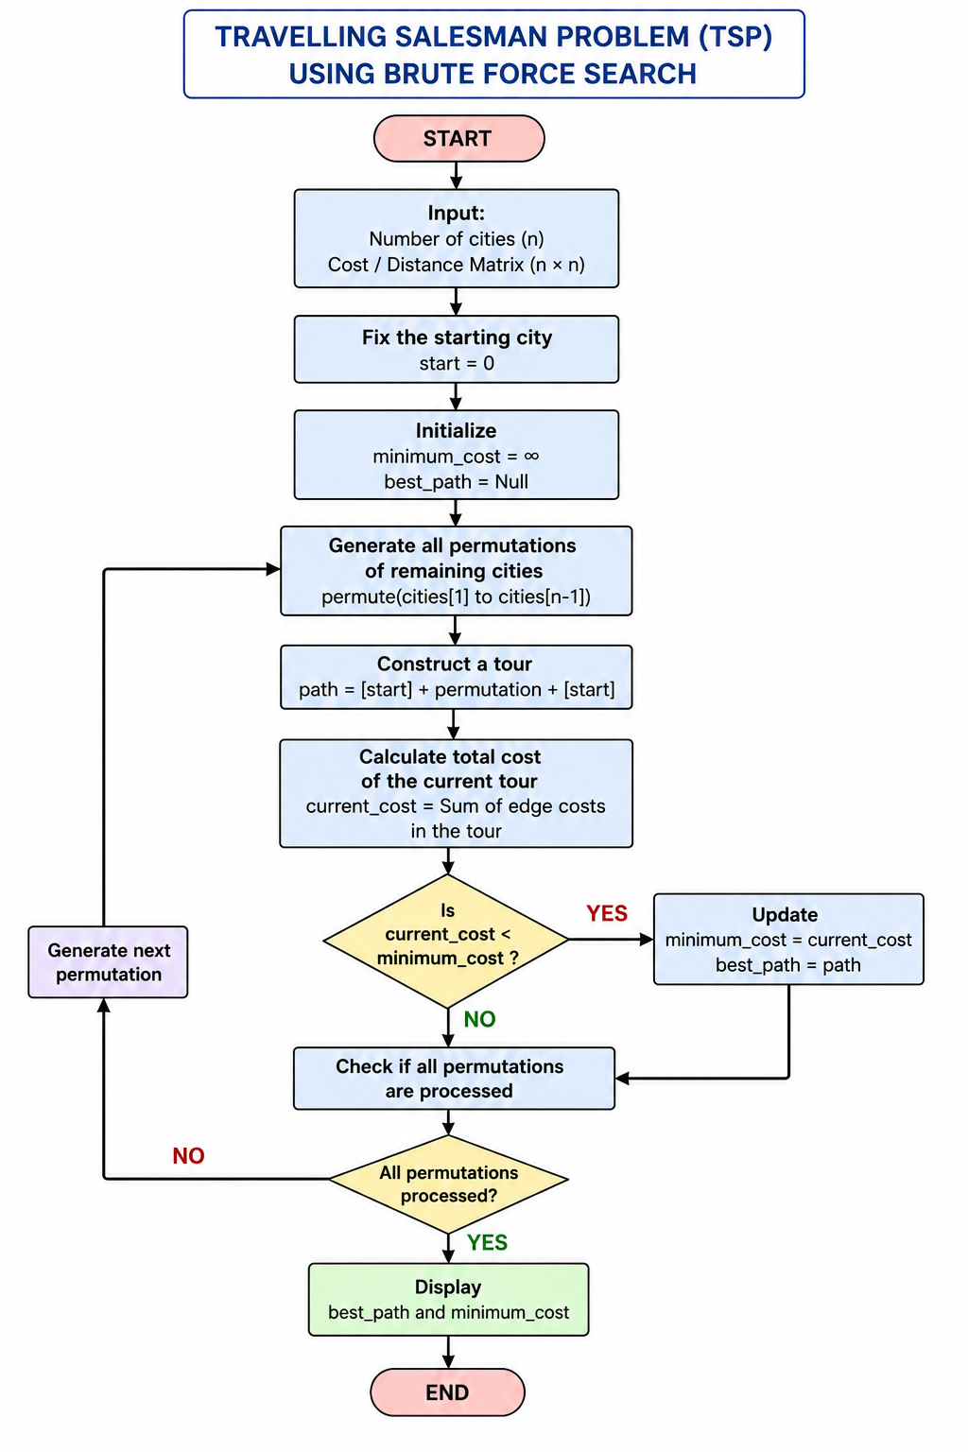

Code:

from itertools import permutations
graph = [
[0, 10, 15, 20],
[10, 0, 35, 25],
[15, 35, 0, 30],
[20, 25, 30, 0]
]
n = len(graph)
cities = list(range(n))
start = 0
minimum_cost = float('inf')
best_path = None
for path in permutations(cities[1:]):
current_cost = 0
current_city = start
for city in path:
current_cost += graph[current_city][city]
current_city = city
current_cost += graph[current_city][start]
if current_cost < minimum_cost:
minimum_cost = current_cost
best_path = (start,) + path + (start,)
print("Travelling Salesman Problem")
print("---------------------------")
print("\nBest Path:")
for city in best_path:
print(city, end=" ")
print("\n\nMinimum Cost =", minimum_cost)

Output:

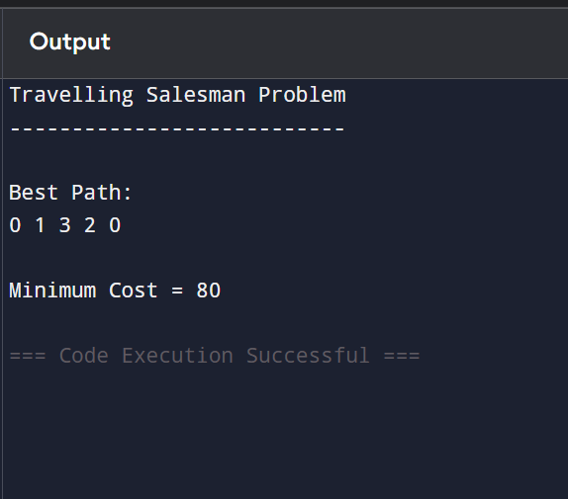

Result :
The Travelling Salesman Problem was successfully solved using the Brute Force Search algorithm. The algorithm examined all possible tours and identified the route with the minimum travel cost.

